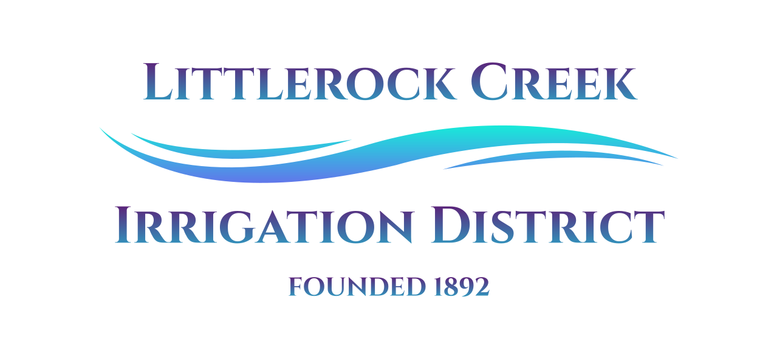
Littlerock Creek Irrigation District

Request for Proposals

For

Littlerock Creek Irrigation District Tank #1 Interior Upgrades

Proposals Due: August 18, 2022, 11 AM

Table Of Contents

- Introduction
- Scope of Work
- Project Schedule
- Submittal Requirements
- Selection Process
- Special Conditions
- Questions

- Introduction:

Littlerock Creek Irrigation District (L.C.I.D.) requests proposals for the interior upgrade to District Tank #1. L.C.I.D.'s Tank #1 is a 1,000,000 Gallon Welded Steel – Ground storage tank 76’-D x 32’-H. The interior of the tank is an epoxy coating in poor condition. The coating in the tank exhibits chalking, cracking, and moderate to heavy corrosion.

- Scope of Work:

The scope of work contains a general outline of the required tasks. Proposals submitted should include a detailed all-inclusive scope of work.

Task 1: The complete interior (100%) shall be abrasive blast cleaned to SSPC-SP No. 10 "Near White" finish.

Task 2: After abrasive cleaning, all surfaces shall be cleaned of dust residue or foreign debris.

- The Contractor/Company will be responsible for cleaning the tank's interior before starting work.

Task 3:A high build epoxy liner manufactured by Tnemec Company shall be applied as follows:

- Primer Coat: One[1] complete coat of Tnemec Series 94-H2O zinc or equivalent shall be applied at the manufacturer's recommended thickness.
- Intermediate Coat: One[1] complete coat of Tnemec Series N140 Epoxy or equivalent shall be applied at the manufacturer's recommended thickness.
- Finish Coat: One[1] complete finish coat of Tnemec Series N140 Epoxy or equivalent shall be applied at the manufacturer's recommended thickness.
- Contrasting Color: Each coat of epoxy paint shall be of contracting color.
- Stripe Coat: One additional coat of epoxy shall be applied by brush and roller to all weld seams.
- After the liner has properly cured, the interior surfaces shall be disinfected per A.W.W.A. Spray Method No. 2(200 PPM)
- The spent abrasive media shall be tested per T.C.L.P.-(8) Heavy Metals as mandated by the State.
- Once the test results confirm the non-hazardous status of the wastes, the spent abrasive shall be disposed of properly.
- The tank shall be sealed and made ready for service.

Task 4: The Contractor /Company will be responsible for the additional tasks before, during, and after the completion of the project.

- The Contractor/Company will be responsible for all permits required to complete work in addition to asset-specific engineering if necessary at no additional charge.
- The Contractor/Company shall not have additional overtime or weekend work charges.
- The Contractor/Company offers a warranty on all work for no less than twenty-four (24) months at the time of competition.

- Project Schedule:

The following dates reflect the anticipated schedule for soliciting proposals, selecting the Contractor/Company, and awarding the contract for the work requested in the R.F.P.

Solicit Proposals August 4, 2022
Proposals Due August 18, 2022
Award Contract August 18, 2022
Kickoff Meeting August - September 2022

- Submittal Requirements:

- Basic Qualifications: Provide basic data relative to the Contractor/Company size, history, personnel, special expertise, and general credits.
- Specific Qualifications: List the Contractor/Company to accomplish the work. Describe who will perform the various tasks, the amount of time, their involvement and responsibilities, and their qualifications. Provide a list of previous projects that show the ability to complete the project.
- Approach to the Project: Include a statement of your approach to the project.
- Past Performance: Submit reference letter/s from prior clients or client representatives.
- Project Fee and Schedule: Submit a project fee and schedule. Include a cost breakdown with the hour specified for each task.

- Selection Process:

The following areas of evaluation will be used:

Experience and Qualifications | 35
Contractor/Companies project approach | 25
Contractor's/Company’s performance records on similar projects | 15
Contractor’s/Company's depth of staff and resources | 15
Other | 10
Total = | 1000

- Special Conditions:

- Littlerock Creek Irrigation District reserves the right to cancel, in part or entirety, the Request for Proposals, including but not limited to selection schedule, submittal date, and submitting requirements.

- Disclaimer of Right of Contract: The R.F.P. does not commit Littlerock Creek Irrigation District to award a contract to or defray any costs incurred in preparing the Proposal according to this R.F.P.

- Costs of Developing Proposal: Costs for developing proposals are the responsibility of the proposing Contractor/Company. Littlerock Creek Irrigation District shall not be responsible for any costs associated with developing proposals.

- Questions:

Questions regarding the R.F.P. can be sent to James Chaisson, General Manager, via email at jchaisson@lrcid.com. Questions concerning information already in the R.F.P. will be answered in writing; questions requiring clarification or additional information will be addressed in an addendum to this R.F.P.

James Chaisson, General Manager
Littlerock Creek Irrigation District
35141 87th Street East, Littlerock, CA 93543
p. (661)944-2015
jchaisson@lrcid.com

